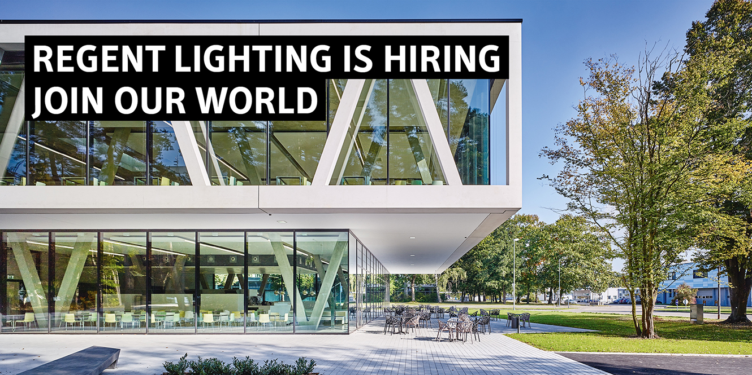

Headquartered in Basel (Switzerland), Regent Lighting employs around 600 people in six countries, is the market leader in Switzerland and one of the leading lighting manufacturers in Europe. Through distribution partners, our products are distributed internationally in 35 countries.

For our new factory in Svilajnac, Central Serbia, we are looking for:

**Software Engineer**

**Your tasks**

* Analyzes functional requirements.
* Develops design concepts for software work products.
* Participates in the analysis, design, development, test, modification and integration of software systems or subsystems for designated products and/or customer applications.
* Understands and works with peripheral elements of assigned software work products (run time environments, databases, networks).
* Develops software requirements, related design, and code.
* Performs software testing.
* Applies and maintains quality standards.
* Assesses severity of problems, determines corrective action, resolves technical problems, and performs fault isolation and implements solutions.
* Revises and updates programs and documentation, including reviewing schedules and milestones.
* Maintains the host environment and toolsets required to implement software deliverables.

**Your profile**

* + Good level of English mandatory
  + German is a strong plus
  + Bachelor or Master in IT
  + Experience in software development (C / C++) as well es web based software development
  + Project Management experience
  + In-depth knowledge in the areas of network technologies, databases and IT security
  + Understanding possibilities and services of cloud systems and know how to administer and configure them

**What we offer**

* An innovative company in a dynamic environment with strong support from Switzerland team
* Living tradition combined with values ​​such as quality and knowledge
* Flexible working hours
* Strong collaboration with Switzerland

If you consider yourself the right person and your professional background matches the vacant position, please send us your CV to e-mail [posao@road.rs](mailto:posao@road.rs)